**PHASE 4 – Product demand prediction using Machine learning**

import numpy as np

import pandas as pd

import os

for dirname, _, filenames in os.walk('/content/PoductDemand.csv.zip'):

    for filename in filenames:

        print(os.path.join(dirname, filename))

import pandas as pd

import numpy as np

import matplotlib.pyplot as plt

from sklearn.model_selection import train_test_split

from sklearn.metrics import f1_score, accuracy_score, confusion_matrix ,classification_report

from sklearn.ensemble import RandomForestClassifier

from sklearn.svm import SVC

from sklearn.tree import DecisionTreeClassifier

from sklearn.ensemble import RandomForestClassifier, AdaBoostClassifier, GradientBoostingClassifier

from plotly.offline import iplot

import plotly as py

import plotly.tools as tls

import pickle

data  = pd.read_csv("/content/PoductDemand.csv.zip")

for ind in data.index:

    continue

def remove_space_between_word(dataset):

    for col in dataset.columns:

        for i in range(len(dataset[col])):

            if (type(dataset[col][i]) == str ):

                dataset[col][i] = dataset[col][i].strip()

                dataset[col][i] = dataset[col][i].replace(" ", "_")

    return data

new_df = remove_space_between_word(data)

new_df.head()

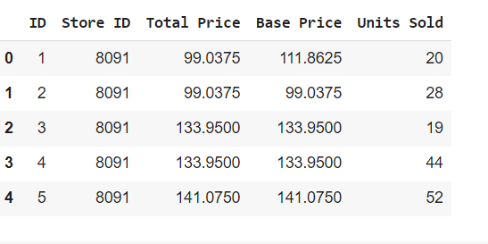

fig = plt.figure(figsize=(5, 5))

ax = fig.gca()

data["ID"].hist(ax =ax)

plt.ylabel("number of apparution in data")

plt.xlabel("UNITS SOLD")

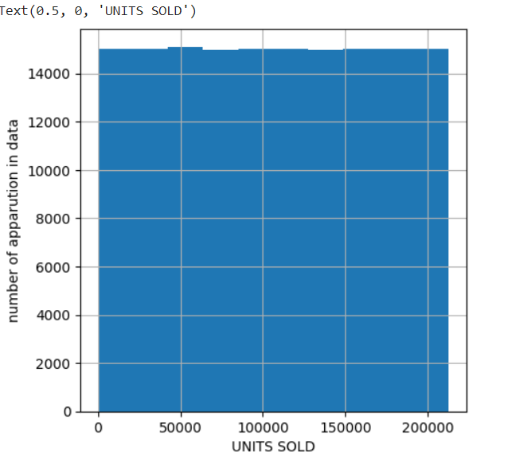

new_df.hist()

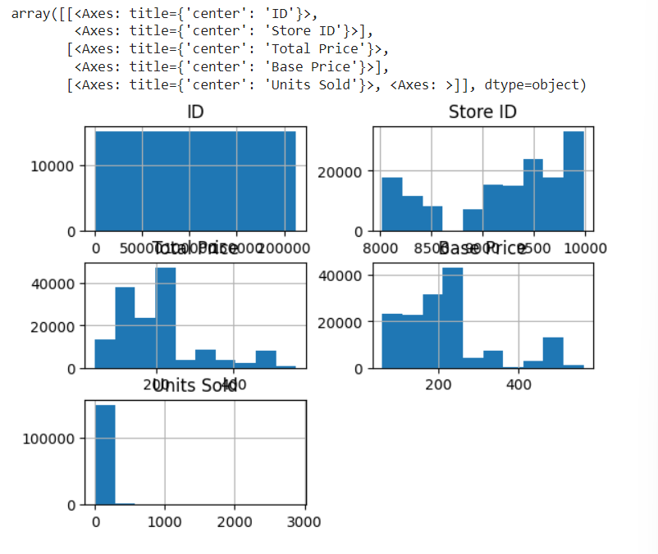

def encode_data(dataset , data_dict_weigth):

    cols = dataset.columns

    for columnName in cols:

        for i in range(len(dataset[columnName])):

            try:

            #print(data_dict[data2[columnName][i]]["weight"])

                dataset[columnName][i] = data_dict[dataset[columnName][i]]["weight"]

            except:

                pass

    dataset = dataset.fillna(0) # put empty cell to 0

    dataset = dataset.replace("Store ID" , 5)

    dataset = dataset.replace("Total Price" , 6)

    dataset = dataset.replace("Base price" , 6)

    return dataset

data_dict = new_df.set_index('ID').T.to_dict()

df = encode_data(new_df , data_dict)

df.head()

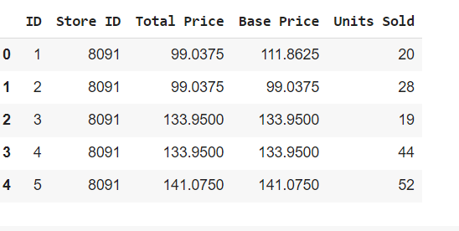

new_df_data = df.drop('ID' , axis =1)

label = data["ID"]

import plotly.express as px

import seaborn as sns

correlations = new_df_data.corr(method='pearson')

plt.figure(figsize=(5, 5))

sns.heatmap(correlations, cmap="coolwarm", annot=True)

plt.show()

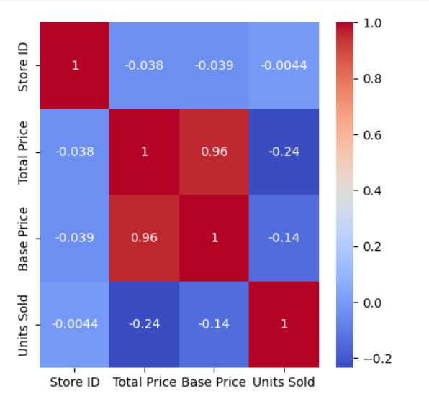

from sklearn.svm import SVC

from sklearn.tree import DecisionTreeClassifier

X_train, X_test, y_train, y_test = train_test_split(new_df_data, label, shuffle=True, train_size = 0.70 )

def fit_eval_model(model, train_features, y_train, test_features, y_test):

    """

    Function: train and evaluate a machine learning classifier.

    Args:

      model: machine learning classifier

      train_features: train data extracted features

      y_train: train data lables

      test_features: train data extracted features

      y_test: train data lables

    Return:

      results(dictionary): a dictionary of classification report

    """

    results = {}

    # Train the model

    model.fit(train_features, y_train)

    # Test the model

    train_predicted = model.predict(train_features)

    test_predicted = model.predict(test_features)

     # Classification report and Confusion Matrix

    results['classification_report'] = classification_report(y_test, test_predicted)

    results['confusion_matrix'] = confusion_matrix(y_test, test_predicted)

    return results

rf = RandomForestClassifier(random_state = 1)

ab = AdaBoostClassifier(random_state = 1)

gb = GradientBoostingClassifier(random_state = 1)

# Fit and evaluate models

results = {}

for cls in [ rf, ab, gb]:

    cls_name = cls.__class__.__name__

    results[cls_name] = {}

    results[cls_name] = fit_eval_model(cls, X_train, y_train, X_test, y_test)

for result in results:

    print (result)

    print()

    for i in results[result]:

        print (i, ':')

        print(results[result][i])

        print()

    print ('-----')

    print()